auto-upload the Allure Report to GitHub Pages

**Step 1: Update playwright.yml to Generate and Store Allure Report**

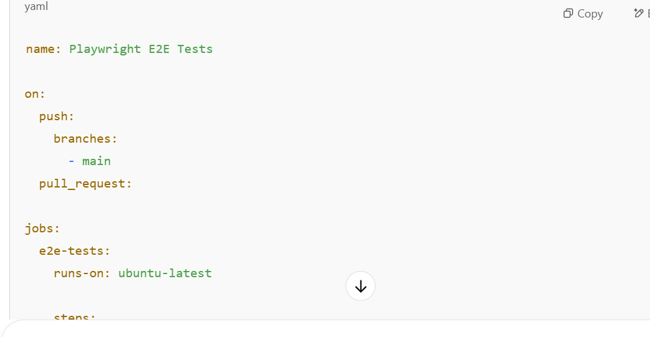

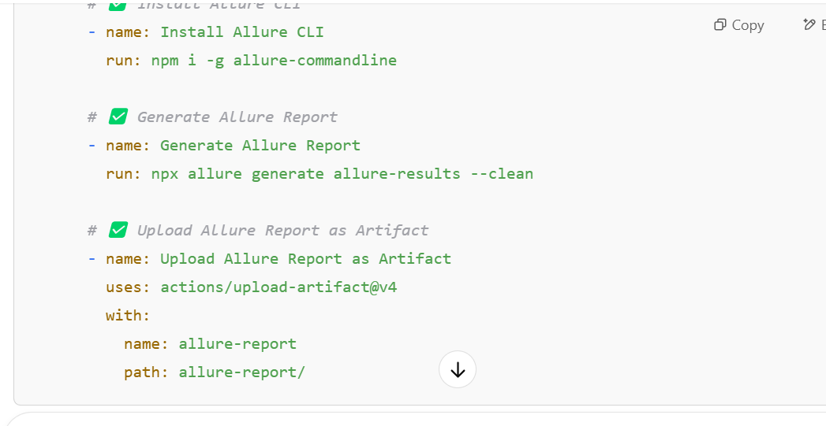**Step 2: Update deploy.yml to Pull the Allure Report Artifact**

